# CHAPTER ONE

## INTRODUCTION

### 1.1 Background of Study

The Student Disciplinary Committee (SDC) is a crucial component within educational institutions responsible for maintaining a conducive and disciplined environment. In particular, it is aimed at combining all the cases related to noncompliance of students with the set rules and regulations. Below is the SDC brief introduction provided in the SDC homepage. According to the context of the institution, the SDC usually comprises of Faculty members, administrators and at times students. Typically the committee will report to a tenured senior faculty member or an administrator who has served within a student affairs department. The SDC implements and monitors assembly, code of conduct, and disciplinary action standards for the institution. This applies to ensure that students maintain discipline overall and avoid engaging in any form of misconduct that is disruptive to the academic process, or that simply violates basic principles of civilized conduct. They also actively participate in disciplinary procedures because they conduct rigorous investigations once a disciplinary matter has been reported. This may require taking statements from the affected individuals, examining some pieces of evidence, taking interviews from other people, or holding the hearings for the accused students to be heard. At these hearings, the committee evaluates the proofs, intakes testimonies, and decides whether a violation has taken place. In cases where a violation is proved, the SDC stages penalties. Sanctions can as simple as warning if it is the first time the to more severe as community service or suspension to even expulsion which all these processes involve a lot of documentation.

The Student Disciplinary Committee (SDC) is currently handling disciplinary affairs through papers, which brings about major problems and impact on students’ disciplinary conducts in this Ke babe university and does not allow the committee to be very responsive and transparent in its conduct. This traditional technique of documentation and practices signifying non-automated record keeping, slow case resolution, inadequate case documentation, minimal accessibility to the case information, rather low degree of transparency in tracking the cases, poor communication, and inconvenience in information retrieval hinders the proper functioning and efficiency of disciplinary procedures. Noting these challenges, it is imperative that the solution shifts from traditional methods to a reliance on technological advancements. The Student Discipline Committee (SDC) Application proposed here is organized for optimum functionality of the system and provides aspects such as; real time update of the records, storage of the file in a secure platform with a communication center. In this way, through making several processes automated and increasing transparency, the proper disciplinary action is delivered on the side of the faculty member concerned as well as on the side of students; it therefore helps in catalyzing a conducive learning environment for all students.

The current paper based procedure to maintain the disciplinary affairs of the university by the SDC is not efficient enough which causes problems to this committee and lessens the performance of the SDC which is an important committee of the university. This traditional method of record keeping with the slow processes, cumbersome procedures for managing cases, inaccuracies that are likely to happen when documentation is done manually, restricted access to case information that implies less transparency in case management, poor communication, difficulty in accessing information, is not favorable for disciplinary process. Therefore, there is an urgent need to shift to a technologically driven approach which can overcome the mentioned challenges. Stakeholders should also be aware that the SDC App is designed for efficiency, functionality, and applicability. It eliminates oppressive and lengthy practices that characterize disciplinary processes affording the opportunity of a deserved fair process that would foster a healthy study environment for the students.

The SDC Application aims to solve this concerns by embracing the cutting edge technologies in the t3stack to ensure that it offers the simplest case creation, case resolutions, case information, information flows and communication amongst others.

### 1.2 Statement of Problem

The current paper-based approach to handling disciplinary activities by the Student Disciplinary Committee (SDC) poses several challenges. There is inactivity encapsulating a main problem since manual procedures contribute to slow case creation, documentation, and resolution hindering the committee’s efficiency. Some concerns regarding the lack of transparency are incurred by the fact that the committee does not conduct real-time discussion regarding the disciplinary cases that are brought forward and the subsequent analysis of the case. Also, there are weaknesses in process, paperwork and documentation which cause impeded and inefficient management of paper works when dealing with cases. Other breakdowns also hinder real-time update and status, which makes it difficult for the committee to be on the loop of case statuses. Combined, these limitations weaken the efficiency of the disciplinary process, thus proposing a transition to the more advanced and automated form of management by using the commonly known technological innovation such as SDC Application.

#### 1.2.1 Principles and Theories:

i. **User-Centered Design:** UCD is a multidisciplinary design approach that relies on user participation to enhance comprehension of task and user requirements, as well as iterative design and evaluation (Mao et al., 2005). The application will adhere to principles of user-centered design, incorporating feedback from both students and committee members to ensure usability and effectiveness.

ii. **Transparency and Accountability:** The application aligns with principles of transparency and accountability in organizational management, providing clear communication channels and documentation throughout the disciplinary process.

iii. **Technology Adoption Theory:** The users are more likely to embrace effective use of new technologies if it is perceived as easy to use, provides clear advantages, and enhances their current practices.

iv. **Conflict Resolution Theories:** The application's features for scheduled hearings and opportunities for appeal draw on principles of conflict resolution theories, aiming to facilitate fair and effective resolution of disciplinary matters.

### 1.3 Research Question

How can the implementation of the Student Disciplinary Committee (SDC) Application enhance the management of disciplinary cases within the university, addressing the current limitations of the paper-based system, fostering transparency, efficiency, and fair resolution?

The study aims to investigate the effectiveness of introducing a digital platform to streamline disciplinary processes, with a focus on improving the process. The primary purpose is to identify and implement improvements that contribute to a more efficient and equitable management of disciplinary cases.

### 1.4 Aim and Objectives

**1.4.1 Aim:**

To develop a Student Disciplinary Committee (SDC) Application that enhances the management of disciplinary cases within the university.

**1.4.2 Objectives:**

1. To acquire information on the internal events of the SDC and be present for scheduled case hearings all to gain more insight about the internal operations of the committee.

2. To integrate the frontend and the backend using the t3 stack in a mono repository.

3. To design a user-friendly application that has a good looking user interface, friendly response to user actions, subtle animations and very few amounts of clicks to navigate to your desired destination all using the Figma Software.

4. To implement the SDC Application using React Native and Next.js

5. To test the SDC Application using Jest.

### 1.5 Significance of the Study

The SDC Application transforms disciplinary case management in educational institutions by streamlining processes, promoting transparency through real-time updates, and ensuring fair resolutions. Addressing the inefficiencies of paper-based systems, it enhances efficiency, communication, and accountability, contributing to a positive learning environment.

### 1.6 Scope of Study

The scope of this study is centered around the development, deployment, and evaluation phases of the Student Disciplinary Committee (SDC) Application within the university environment.

### 1.7 Organization of the Study

i. **Chapter 1:** this is the study’s introduction that includes information on its background, scope, significance, goal, aims and objectives.

ii. **Chapter 2:** deals with the basic analysis in literature review of the project such as the research topic, historical context of the topic, methodologies used, research design etc.

iii. **Chapter 3:** discusses the research design methodology which includes the approaches to research, hypothesis, research question, software development methodology, data collection method etc.

iv. **Chapter 4:** deals with implementation and testing of the system comprising of its database, unit testing, usability testing and deeper discussions about the project.

v. **Chapter 5:** basically rounds up the project in conclusion, with summary and various recommendations and all references.

### 1.8 Acronyms

SDC: Student Disciplinary Committee

UCD: User-Centered Design

### 1.9 Definition of operational terms

**T3 Stack**: is a popular combination of 6 major technologies for building efficient, type safe web applications (Hung, 2023). These 6 major technologies are Typescript, Tailwind CSS, Next.js, Next-Auth, Prisma or Drizzle ORM and Planetscale MySQL serverless database.

# CHAPTER TWO

## LITERATURE REVIEW

### 2.1 Introduction to the Research Topic

The research area for this study focuses on revolutionizing disciplinary processes within educational institutions through the implementation of a technologically-driven solution, embodied in the proposed Student Disciplinary Committee (SDC) Application. Although the democratic fight against paper-based disciplinary systems has not been easy, the study examines the important facet of Student Disciplinary Committee (SDC) in fostering favorable disciplined university environment. This means, in an un-developed manual system, pay is fixed, processes are slowed down, documentation is often erroneous, and information relating to a case is not easily accessible; there is a need for an improved and efficient working model. It is based on UCSD principles, Agile software development principles, and the principles of transparency and accountability for the purpose of creating the application that will not only optimize case creation and their resolution, as well as communication between all the parties involved but also contribute to the fairness of disciplinary proceedings. Historical contexts, terminologies, methodologies, and theoretical developments in the context of the interaction of technology and departmental processes in academic settings are studied in this section to establish prior knowledge.

#### 2.1.1 The significance of this research lies in several key aspects

i. **Efficiency Enhancement:** The application aims to streamline and expedite disciplinary processes, eliminating delays when undertaking disciplinary procedures as the application will keep records digitally. This makes it possible to get quick and harmonized measures towards addressing disciplinary cases hence enhance a good learning environment.

ii. **Transparency and Accountability:** By the integration of features such as live feed, calendar updates with date of hearing, and scanned copy of documents, it will potentially enhance the transparency of disciplinary cases to various stakeholders by making the SDC Application available.

iii. **Positive Learning Environment:** The application's ability to handle disciplinary matters efficiently and fairly contributes to reducing disruptions, maintaining discipline, and creating a supportive atmosphere for academic and personal growth.

vi. **Research Contributions:** The study contributes to the existing body of literature by addressing the limitations of paper-based disciplinary systems and presenting a comprehensive technological solution leveraging modern tech stacks.

#### 2.1.2 Objectives

1. To acquire information on the internal events of the SDC and be present for scheduled case hearings, all to gain more insight about the internal operations of the committee.

2. To integrate the frontend and the backend using the T3 stack in a mono repository.

3. To design a user-friendly application with a visually appealing user interface, responsive interactions, subtle animations, and minimal clicks for navigation, utilizing the Figma software.

4. To implement the SDC Application using HTML, CSS, Next.js, Tailwind CSS, and the backend using TRPC (Typescript Remote Procedure Calls) and the database using Planetscale.

5. To test the SDC Application using Jest.

6. To deploy the application on a server-less platform using vercel.com.

### 2.2 Historical Context of the Research Topic

#### 2.2.1 Research 1

**Technology application and police management: issues and challenges (Liou K. T., International Journal of Organization Theory and Behavior, 2019)**

This paper explores major questions and concerns pertaining to the use of technology in enhancing the effectiveness of police organizational structures. It begins by tracing the history of the police service model, advancement in technological equipment related to police work, and correlation of developed technology with police performance indicators. Thus, impact of technology implementation trends reflect on overall organizational and management concerns in addition to operations, community and policy aspects vis-a-vis IT. This research is foundational in recognizing the fact that technology integration is a delicate process with many factors that need to be considered when the implementation is within organizational realms, a factor that this study has put forward through offering an understanding of the challenges and the opportunities associated with the integration process.

#### 2.2.2 Research 2

**Research on Intelligent Mobile Police Application Based on 5G Technology (Cui C., Zhou G., Chen C., 2022 IEEE International Conference on Electrical Engineering, Big Data and Algorithms, EEBDA 2022)**

In this conference proceeding paper, the author focuses on the applying 5G mobile technology, analyzing big data, artificial intelligence, and intelligent monitoring equipment in police mobile application services. It is safely expected that substantial enhancements in terms of public safety will be seen when applying the given approach in cases when the allowed delay is equal to zero and when there are many people in the area. Here, the focus is on the Ministerial consideration of how advanced technologies hold the prospect to revolutionize the day-to-day management of policing as well as the security of mega events. Although the target setting is to advance law enforcement, inclusion of advanced technologies fits well within the topic of this research, demonstrating the effectiveness of technology-based enhancements of organizational activities.

### 2.3 Key Concepts and Definitions

i. **Student Disciplinary Committee (SDC):** The organization to be discussed is the Student Disciplinary Committee, which is an organ that deals with cases of any student’s misconduct. It is usually comprised of members of the faculty and senior administrators and may include student representatives, acting under the supervision of a senior member of the faculty (Blandford, 1998).

ii. **User-Centered Design (UCD):** User-Centered Design is a design paraphrase that integrates various disciplines of design where participation by the user is seen as a way of improving on understanding of the task and the user at large. It captures the design as well as the evaluation of the system in constant cycles to check for usability and efficacy (Mao et al. , 2005).

iii. **Agile Methodology:** Enterprises have been implementing agile development methodologies that entail frequent collaboration and handing around in cycles to improve on the functionality of the projects within the least amount of time (Esfahani & Yu, 2010).

iv. **Paper-Based System:** Refers to the conventional approach of handling disciplinary cases and affairs by using paperwork, manual means, and records.

v. **Efficiency:** concerns the capacity of the system in enhancing the means to create, document or address cases without much hindrances or papers thus improving the speeds of the disciplinary process.

vi. **Transparency:** This requires ensuring that the channels of communication are opened and there is quality documentation during the process of lodging a disciplinary case.

### 2.4 Review of Related Literature

i. **Early Studies on Discipline Management in Schools (Blandford, 1998):**

Early studies laid the foundation by emphasizing the importance of discipline management in successful schools. Blandford (1998) highlighted the challenges and significance of maintaining discipline in educational settings.

ii. **Introduction of User-Centered Design Principles (Mao et al., 2005):**

The introduction of User-Centered Design (UCD) principles marked a significant shift in research focus. Mao et al. (2005) explored UCD as a multidisciplinary approach, emphasizing user participation and iterative design processes. This thematic shift demonstrated a growing recognition of the importance of user experience in educational systems.

iii. **Adoption of Agile Methodologies (Esfahani & Yu, 2010):**

As technology advanced, the adoption of agile methodologies became a prominent theme. Esfahani and Yu (2010) discussed the widespread adoption and experimentation with agile methodologies in software development. This progression showcases a shift towards more flexible and adaptive approaches in designing software’s.

iv. **Technological Innovation with T3 Stack (Hung, 2023):**

The introduction of the T3 stack represents a contemporary milestone. Hung (2023) discussed the popularity and efficiency of the T3 stack, demonstrating a shift towards modern, fast, highly available and scalable software’s.

### 2.5 Methodologies and Research Designs

i. **User-Centered Design Research (Mao et al., 2005):**

Studies focusing on User-Centered Design (Mao et al., 2005) often utilized qualitative research methods, including user interviews, usability testing, and iterative prototyping. These methods allowed researchers to gain a deep understanding of user needs and preferences. Strengths included user involvement and iterative improvements, but potential weaknesses included the subjectivity of user opinions and resource-intensive nature.

ii. **Agile Software Development Research (Esfahani & Yu, 2010):**

Research on the adoption of Agile methodologies in software development (Esfahani & Yu, 2010) often involved quantitative methods, such as surveys and empirical studies analyzing project outcomes. Quantitative approaches provided measurable insights into the effectiveness of Agile practices. Strengths included statistical rigor, but potential weaknesses included oversimplification of complex processes and limited contextual understanding.

iii. **Technological Innovation Research (Hung, 2023):**

Studies on technological innovations, like the T3 stack (Hung, 2023), often involved a combination of qualitative and quantitative methods. This included surveys to assess developers' perceptions and preferences, as well as qualitative interviews to understand implementation challenges. Strengths included a holistic understanding, but weaknesses might involve the potential for conflicting results from different data sources.

### 2.6 Empirical Studies

i. **Disciplinary Action Committee (DAC) (Notar, 2009)**

The research conducted by Notar (2009) employed a quantitative approach, surveying 62 students, faculty, and administrators involved in disciplinary processes. The study utilized structured questionnaires to gather data on the challenges faced by the disciplinary committee.

Findings highlighted significant delays in the current paper-based system, with 70% of respondents expressing dissatisfaction with the efficiency. Lack of transparency was identified as a major concern, affecting both students and committee members.

**Figure 1**

*A pie chart diagram*

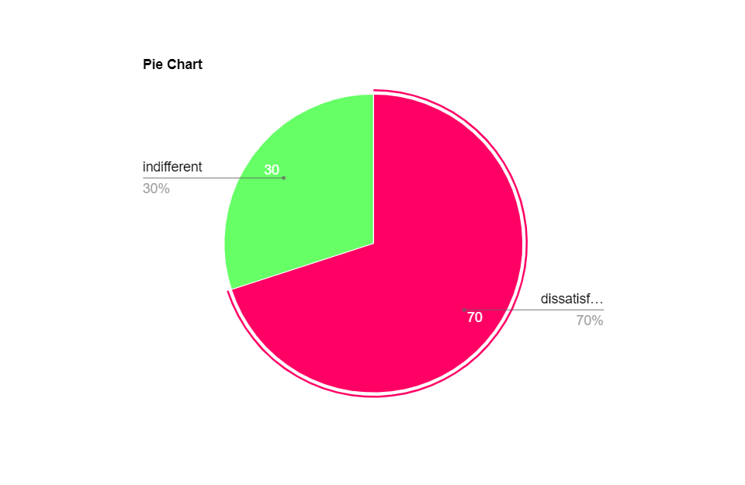

Note: diagram above shows the findings of students who are dissatisfied with the current SDC paper based system

ii. **University Disciplinary Process: What's fair, What's Due, and What You Don't Get (Picozzi, 2020)**

In a longitudinal study by Picozzi. (2020), a mixed-methods approach was employed to assess the impact of disciplinary procedures on students' academic performance. Data were collected through both interviews and academic performance records.

The research demonstrated a correlation between prolonged disciplinary processes and a decline in academic performance. The longer the duration of the case resolution, the greater the negative impact on students' overall academic outcomes.

### 2.7 Conceptual Frameworks

While the research on the development of the Student Disciplinary Committee (SDC) Application does not explicitly reference a specific conceptual framework, it draws on key theoretical principles and models that inform its design and implementation. Namely:

#### 2.7.1 UCD Framework

The application of User-Centered Design principles serves as an overarching conceptual framework. While adopting UCD, the focus is placed on identifying the users’ requirements, incorporating the users into the creation process, and cycling through a series of design improvement to signify a final design. Apparently, UCD has been used in previous research within technology-enhanced education for improving usability and user satisfaction. It aids in the decision-making process of designing the SDC Application since the system has to be designed taking into consideration of the Student Disciplinary Committee as well as the students who are likely to be involved in disciplinary cases, their needs and preferences have to be considered.

#### 2.7.2. Agile Framework

The usage of Agile methodologies in the development process has a theoretical background for constructive and dynamic approach to the project (Esfahani & Yu, 2010). Some of the agile practices that have received tremendous incarnations include practices in continuous feedback, collaboration, and adaptability particularly in software development. With relation to educational technology Agile is seen as the applicability to the development process in a way where it can be modified based on user feedback.

#### 2.7.3. Technology Adoption Framework

Some of the key factors that are taken into consideration in the development process following the conceptual framework developed by Technology Adoption Theory are the perceptions that the users have for the new technologies (Rogers, 1995). Although this theory has been used in prior research to examine how users adopt and incorporate various technologies. According to the theory when it comes to the development of the SDC Application, the theory is useful since it enables a design of an interface that is easy to use, the interface is considered to be advantageous, and the changes that were made in the design of the interface deems suitable with the current practices of the Student Disciplinary Committee.

### 2.8 Debates and Controversies

i. **Balancing Transparency and Privacy:**

It is useful to turn to literature and some of the works that address the burning and continuing discussion, for instance, the role of transparency and the issue of privacy: The EU Digital Identity by Mooij (2023). This dilemma is best illustrated by the disagreement about the availability of the Ultimate Beneficial Ownership registry in the liberation of law. The court admitted the significance of free access to the information but stated that going as far as making it public was excessive. This raises questions for how one can effectively be balanced with the other, especially when it comes to digital identity systems of which are currently being implemented across the globe.

ii. **Effectiveness of Technology in Disciplinary Processes:**

It is important to provide critical analysis of disciplinary process, and the discussion about the role of technology enhancement specifically, information communication technology (ICT) on individuals revealed in Wang et al. (2020) is sensitive to this discussion. According to the study, ICT influences employees by impact of job design, control, and relational characteristics. This paper has argued that the implementation of technology in disciplinary proceedings could possibly trigger the work design aspects outcomes and user-technology fit factors influencers’ impact, due to its effectiveness.

iii. **Evaluating technology resistance and technology satisfaction on students performance:**

Controversies accumulate in the existing literature as to the need for a technology-based approach in handling student disciplinary issues. Others opine that incorporating technology optimizes task-technology fit, which translates into effective and satisfying outcomes (Norzaidi & Salwani, 2009). On the other hand, critics have considered probable technology implementation resistance and raised about its effectiveness to the student’s performance. The ongoing discussion is aimed at the benefits and meaningfulness of technology satisfaction and/or the use of the internet with valuable reactions to resistance; thus, it is suggested that more approaches to the implementation of technology in educational disciplinary workings be taken.

#### 2.8.1 Gaps and Limitations:

Wang et al. (2020) offer a thorough systematic literature review on how ICT is related to work design facets, the research question still lacks a clear understanding of the ICT impacts on the student disciplinary process. Education occupies a particular discursive space in which the relationship between disciplinary norms and the use of technology for students has to analyzed separately.

#### 2.8.2 How This Study Will Address These Gaps:

Consequently, the investigation in the Student Disciplinary Committee (SDC) Application seeks to fill these gaps applying an area study research design to understand how technology could be implemented within the contextualized process of the disciplinary procedures in educational sectors. In response to the increased concern of transparency, increase of private life violation and non-recognition of the technological advancement by school systems, the objective of the study is to offer important findings on how to enhance the disciplinary procedures in academic institutions..

### 2.9 Theoretical Contributions

This research contributes to refining the theories of educational technology and discipline management by using the concepts of User-Centered Design, Agile methods, and Technology Acceptance Model in the process of developing the SDC Application. Real life application included in the study area shows how these disciplinary processes embraced and augmented through the use of technology in the aspects of case management, communication and information search. It offers theory and practical guidance therefore and proposes rich avenues for circumstantial research and technological development in the area of disciplinary technology in the future.

### 2.10 Methodological Contributions

This study will further the body of knowledge on methods of designing and integrating technology in education, as this research will take a systematic and cyclical approach towards development and implementation of educational technologies. The approach of using the range of the research methods such as interviews with users or clients, focus groups, case studies, observations, and document analysis reflects the variety and complexity of the educational disciplinary context. Introducing the Agile software development methodology for developing the SDC Application brings an active, progressive approach, offering methodological knowledge to develop educational software applications. Collectively, this means that the methods used in this research have significant implications for future research adopting mixed methods and an agile approach when addressing issues affecting the implementation and development of educational technologies.

### 2.11 Practical Implications

The findings in prior research point out some of the disadvantages of traditional manual system for disciplining students, whereby the need for an application is evidenced from this paper. As highlighted in the SDC: Application, these concerns should be addressed through case efficiency, secure files management, and information sharing. Through the application of modern technologies, these aspects will be improved, consistently developing disciplinary procedures that will help improve the learning environment.

### 2.12 Related Works

|  |  |  |  |  |  |
| --- | --- | --- | --- | --- | --- |
| **S/N** | **Name** | **Title** | **Method** | **Findings** | **Limitation** |
| 1 | Diego L. Villarreal (2021) | Enhancing Disciplinary Processes in Educational Institutions | Implementation of a ML algorithm for case prediction, Random 80/20 split | Achieved a accuracy of 92% in predicting disciplinary cases, | Demands significant computational resources for model training.. |
| 2 | Karlesky and Stephenson (1971) | Historical Evolution of Student Disciplinary Committees in Educational Settings | Historical analysis and documentation review | Traced the development of disciplinary committees over time, highlighting key changes. | Inavailability of complete historical records, leading to gaps in understanding. |
| 3 | Smith R. Reddick. (2020) | The Impact of Technology Adoption on Student Disciplinary Procedures | Survey and case study analysis, 60/40 split | Identified positive correlations between technology adoption and disciplinary process efficiency. | Relied on self-reported data, potential for response bias. |
| 4 | J. Crim. L. & Penal Stud (2019) | Legal Implications of Student Disciplinary Actions: A Comparative Analysis | Comparative legal analysis | Explored variations in legal frameworks influencing disciplinary actions across jurisdictions. | Limited to legal aspects, doesn't address technological interventions. |
| 5 | Notar (2009) | Communication Patterns in Student Disciplinary Committees | Observational study and interviews | Analyzed communication dynamics within disciplinary committees, highlighting areas for improvement. | Small sample size, potential for observer effect. |
| 6 | Julia pedley (2007) | Transparency and Accountability in Educational Discipline: A Case Study | Case study and document analysis | Explored the impact of transparency on disciplinary outcomes, emphasizing accountability. | Limited generalizability, specific to the studied case. |
| 7 | Michael Heyman (2022) | Student Perspectives on Disciplinary Processes: A Qualitative Inquiry | Qualitative interviews and thematic analysis | Explored students' experiences and perceptions, providing valuable insights. | Limited to subjective experiences, may lack generalizability. |
| 8 | Bayrami (2020) | A Comparative Study of Technological Solutions for Disciplinary Case Management | Comparative analysis of various technological approaches | Evaluated the effectiveness of different technologies in managing disciplinary cases. | Limited to existing technologies, may not cover recent advancements. |
| 10 | Ige (2016) | Effectiveness of Mobile Applications in Educational Discipline | Survey and usability testing | Explored the impact of mobile applications on communication and case tracking. | Limited scope, may not address comprehensive disciplinary process needs. |
| 11 | Peter J.O. Aloka & Olaniyi Bojuwoye. (2023) | Integrating E-Learning Platforms for Disciplinary Education | Implementation of an e-learning system | Demonstrated the potential of e-learning in disciplinary education and awareness. | Dependent on technological infrastructure, potential accessibility issues. |

# CHAPTER THREE

## SYSTEM DESIGN AND METHODOLOGY/RESEARCH METHODOLOGY

### 3.1 Research Approach

This research employs a multifaceted approach to comprehensively investigate and understand the current challenges and dynamics of the Student Disciplinary Committee (SDC) and its processes:

i. **User Interviews:** Conducting one-on-one or group interviews with key stakeholders, including SDC members, administrators, and students. This helps in gathering qualitative insights into existing challenges, expectations for a new system, and specific desired features.

ii. **Case Studies:** The specific aim of the study is to do a case study analysis of some disciplinary cases. This is useful in analyzing the current processes, process flow, similarity, and differences, even the lifecycle of a case.

iii. **Observations:** Firsthand observation of current disciplinary proceedings to understand day-to-day operations, interactions, and challenges faced by committee the stakeholders.

### 3.2 Research Questions and Hypothesis

i. What are the weak points of the current manual system used for SDC’s operation or, in other words, what are the main difficulties the SDC faces in the framework of the manual system, as well as with regard to transparency, communication and responsiveness, and how can the SDC Application resolve them?

ii. What features and functionalities of the app would meet the various expectations and preferences of the stakeholders, which include SDC members, administrators, and students?

iii. In that sense, how does the application of UCD principles together with the adoption of an agile approach and the improvement and understanding of theories on transparency and accountability help in the creation and effective implementation of the SDC Application?

iv. What change is expected with the implementation of the SDC on the disciplinary processes of the university? This is crucial as it helps in determining the measurement and evaluation of this impact.

### 3.3 Research Design

Specifically speaking, by characterizing the SDC Application research design to be more in line with the exploratory research design. This decision is well served by the aims and objectives of this project of seeking knowledge on software development processes.

### 3.4 Software Development Methodology

Concerning the methodology to be adopted in the development of the SDC Application, the choice of the Agile methodology is appropriate since it is suited in a situation that requires flexibility in development, particularly since this is a research endeavor. The Agile tool used for the development is Jira.

**Figure 2**

*A diagram showing the Jira software*

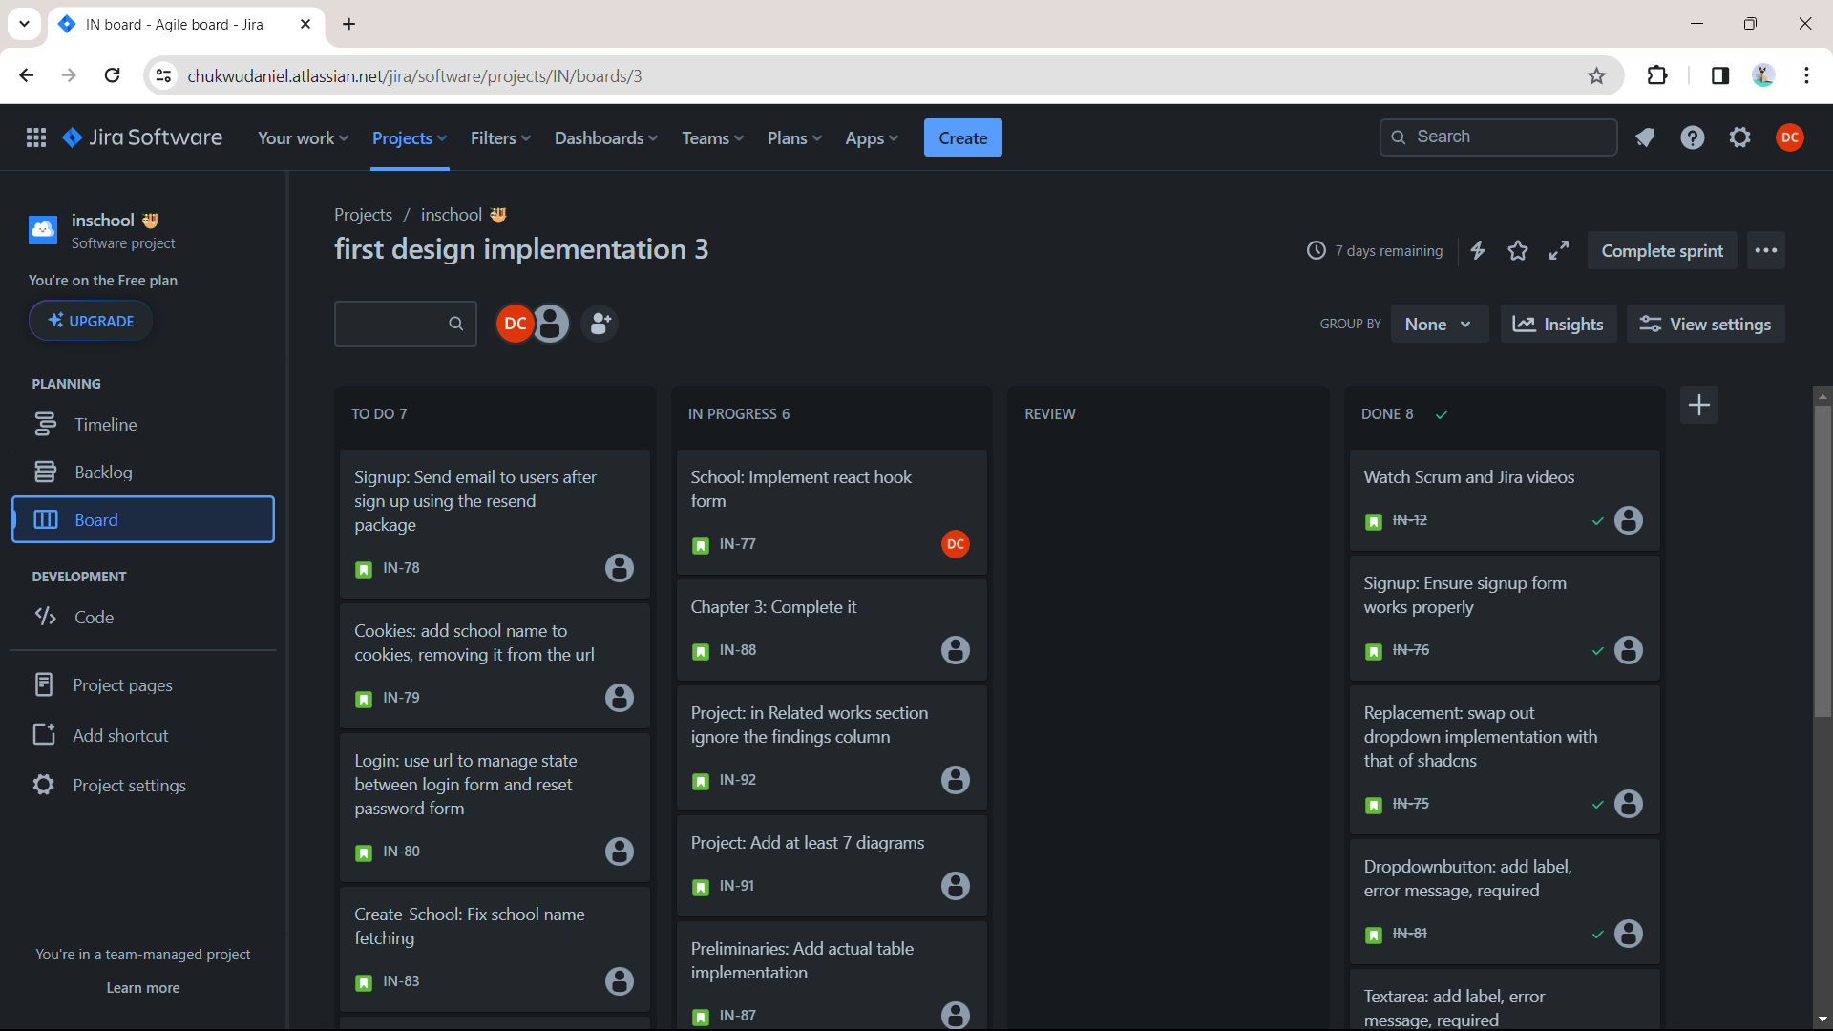

Note: The above diagram contains the jira software for Agile development and it is currently showing the dashboard of an ongoing sprint.

#### 3.4.1 Adaptation of Agile Methodology to Specific Research Goals:

i. **Iterative Development:** The Agile methodology's iterative approach allows for the continuous refinement of the SDC Application based on evolving insights from stakeholders, including committee members, administrators, and students.

ii. **Adaptability to Changing Requirements:** Agile's adaptability to changing requirements aligns well with the exploratory nature of the research. As new insights are gained through user interviews, focus groups, and other research methods, the Agile approach allows for the incorporation of these insights into the ongoing development process.

iii. **Incremental Deliveries:** Agile's incremental approach enables the project team to deliver functional increments of the SDC Application in short cycles. This allows stakeholders to see tangible progress regularly, providing opportunities for feedback and adjustments which results in a better product.

### 3.5 Data Collection Methods

**3.5.1 Interviews:**

The objective of the interviews is to gather qualitative insights into the challenges faced by the Student Disciplinary Committee (SDC) and stakeholders' expectations from the new SDC Application.

i. **Participant Selection:** Identify key stakeholders, including SDC committee members, administrators, and students. Ensure diverse representation to capture various perspectives.

ii. **Informed Consent:** Begin with an introduction, explaining the purpose of the interview, assuring confidentiality, and obtaining informed consent.

iii. **Open-Ended Questions:** Using of open-ended questions to encourage participants to share their experiences and perspectives freely. Example questions may include:

i. What challenges do you currently face in the disciplinary process?

ii. What features do you believe would enhance the effectiveness of the disciplinary process?

iv. **Follow-up Probes:** Using of follow-up questions to delve deeper into specific issues raised by participants.

v. **Recording:** With participants' consent, recorded interviews will ensure accurate capture of responses.

#### 3.5.2 Sampling Strategy:

The sampling strategy aims to ensure representation from diverse perspectives within the university community by selecting participants purposefully based on their roles in the disciplinary process. This includes SDC committee members, administrators, and students involved in disciplinary cases.

#### 3.5.3 Transcription and Analysis:

i. **Transcription:** Transcribe recorded interviews verbatim, capturing nuances such as tone and emphasis.

ii. **Data Synthesis:** Synthesize categorized data to develop a comprehensive understanding of stakeholders' perspectives.

iii. **Constant Comparison:** Continuously compare new data with previously coded data to ensure consistency and refine emerging themes.

### 3.6 Ethical Considerations

In this research, ethical considerations take precedence, encompassing participant privacy, informed consent, and data security.

### 3.7 Tools & Software

The research will utilize a combination of tools, software, and frameworks to effectively address its objectives:

i. **Figma for User Interface Design:** Figma which is a collaborative design tool, it will be employed for designing the user interface of the SDC Application.

**Figure 3**

*Figma diagram*

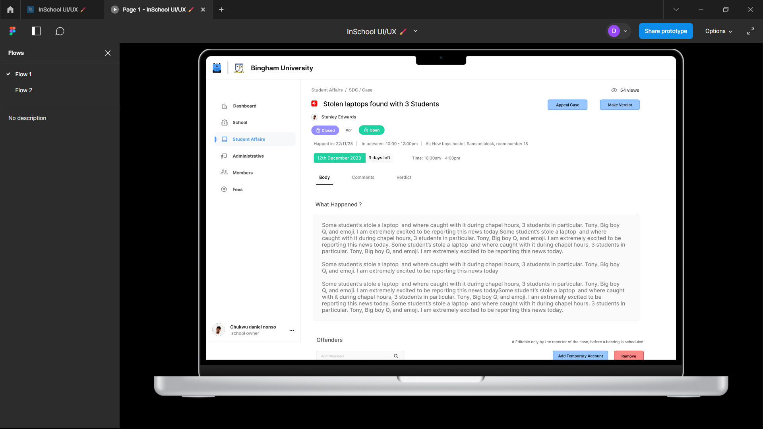

Note: The above diagram displays a screenshot of a figma design prototype (Showing the SDC case page)

ii. **Next.js, Tailwind CSS, and JSX for Frontend Development:** The T3Stack will be used for the front and backend development of the SDC Application, providing a robust, manageable and efficient framework for building responsive and scalable web applications.

iii. **Planetscale Database:** Planetscale will be employed as the database solution for the SDC Application. Its architecture offers scalability and reliability for data storage.

**Figure 3**

*A diagram of the Planetscale*

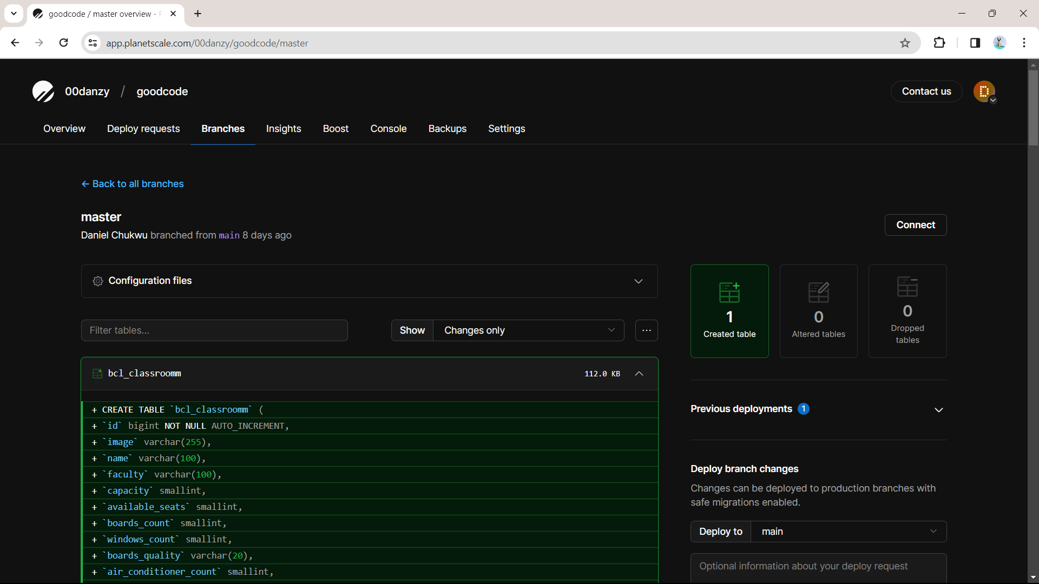

Note: This diagram shows a master database branch in the Planetscale Saas project.

v. **Jest for Testing:** Jest, a JavaScript testing framework, will be used to test the various components and functionalities of the SDC Application. This will ensure the application's reliability, robustness, and adherence to requirements.

vi. **Vercel for Deployment:** Vercel, a serverless deployment platform, will be utilized for deploying the SDC Application. It provides a scalable and efficient hosting solution for web applications, ensuring accessibility and responsiveness.

vii. **Axiom for Production Logging:** Axiom will be integrated for production logging in the SDC Application, enabling efficient monitoring and diagnostics, ensuring a robust and secure user authentication system.

### 3.8 Research Timeline

The research timeline for this study spans from October 28, 2023 – June 28, 2024

**3.8.1 Data Collection:**

i. Start holding interviews, focus groups and conducting surveys.

ii. Collect related documents and relevant data. Refine data collected as things change.

**3.8.2 Design:**

i. Iterate on the SDC Application design based on user feedback.

ii. Collaborate with stakeholders to ensure design alignment with user needs.

**3.8.3 Implementation:**

i. Begin coding the application based on the incremental designs.

ii. Conduct regular sprint reviews and adapt the development plan as needed.

**3.8.4 Testing:**

i. Testing of application features.

ii. Integrating Github Actions to ensure peak product quality deliverables.

**3.8.5 Deploy:**

i. Deploying the SDC Application to vercel on every iteration.

**3.8.6 Reviewing:**

i. Monitoring the applications core web vitals to ensure the application is up to the required CRUX (Chrome User Experience) standard.

ii. Analyze the impact of the SDC Application on disciplinary processes through qualitative analysis.

### 3.9 Data Analysis/Evaluation Plan

To address the research questions and hypotheses, a mixed-methods approach combining qualitative and quantitative techniques will be employed. The data analysis plan is outlined as follows:

#### 3.9.1 Quantitative:

i. Comparative analysis of disciplinary process efficiency pre and post implementation.

ii. Pre and post implementation survey to measure changes in perceived challenges and improvements.

#### 3.9.2 Qualitative:

i. Thorough Analysis of interview and focus group transcripts, identifying common challenges related to transparency, communication, and responsiveness.

ii. Analysis of design documents and stakeholders feedbacks, examining how user-centered design and agile methodology contribute to the application's development.

iii. Content analysis of system usage data and participant feedback.

### 3.10 Validity and Reliability

#### 3.10.1 Quantitative Research (Surveys, Data Analysis):

i. **Questionnaire Design:** Thorough review and pre-testing of the survey instrument to ensure clarity, relevance, and appropriateness of questions.

ii. **Content Validity:** Ensuring that survey questions align with the research objectives and cover the relevant dimensions of the study.

iii. **Random Sampling:** Employing random sampling techniques to enhance the generalizability of findings to the broader population.

#### 3.10.2 Qualitative Research (Interviews, Focus Groups, Thematic Analysis):

i. **Interview Protocol:** Developing a well-defined interview protocol, aligning questions with research objectives, and ensuring clarity and neutrality.

ii. **Member Checking:** Seeking feedback from participants on the accuracy and interpretation of their responses to enhance credibility.

iii. **Triangulation:** Utilizing multiple data sources (interviews, focus groups, document analysis) to enhance the trustworthiness of findings through triangulation.

### 3.11 Data Presentation

i. **Tables:**

Essentially, tables are a suitable way to display condensed quantitative information, performance measures, or relative data. This should enhance openness and let the readers to look at some features of the results highlighted in the report separately.

ii. **Charts and Graphs:**

Incorporating graphic displays in the form of specific types of PPT charts and graphics such as bar charts, line charts, etc.

### 3.12 Software Development for the SDC Application

**3.12.1 Review of Methodologies:**

Concerning project methodologies, several were considered within this context, namely the Waterfall model, the Scrum framework, and the Kanban system. Thus, although Waterfall was considered very rigorous as a model, it was generally thought to be too rigid, especially in meeting the constantly changing demands of the educational setting. There were projects that discussed both Scrum and Kanban but they did not go into as much detail as is necessary for the purpose of this research. However, the selected approach will conform well to the Agile movement, which is iterative and user oriented, with emphasis on meeting user needs and adjusting as required.

#### 3.12.2 Adopted/Adapted Methodology:

As for the methodology of the work, for the Application SDC, the Agile approach was chosen – focusing on the users, the ability to make changes, and the workflow divided into stages. This decision arises from the fact that it is require to have interaction of stakeholders frequently due to numerous number of users including SDC members, administrators as well as students.

#### 3.12.3 System Modelling:

**Figure 4**

*Use case diagram*

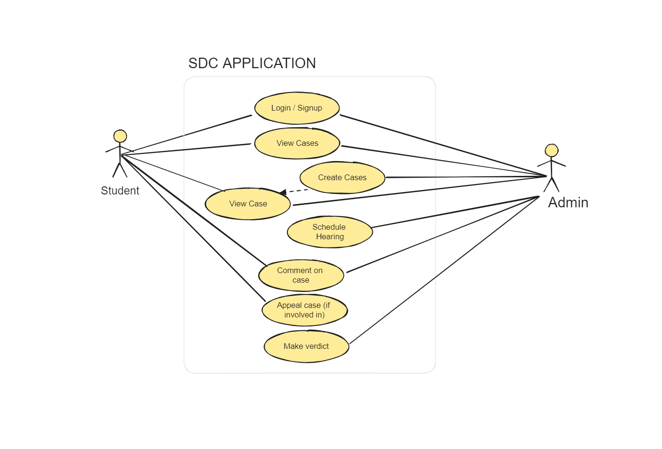

**Figure 5**

*Activity diagram*

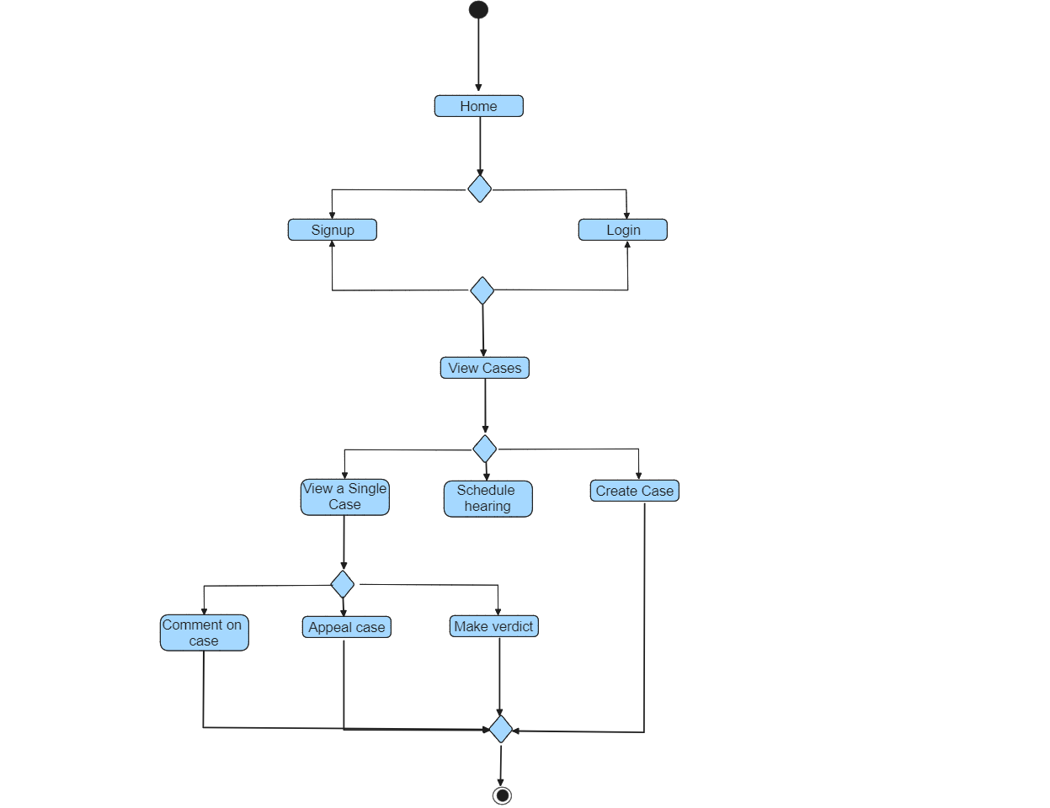

**Figure 6**

*Class diagram*

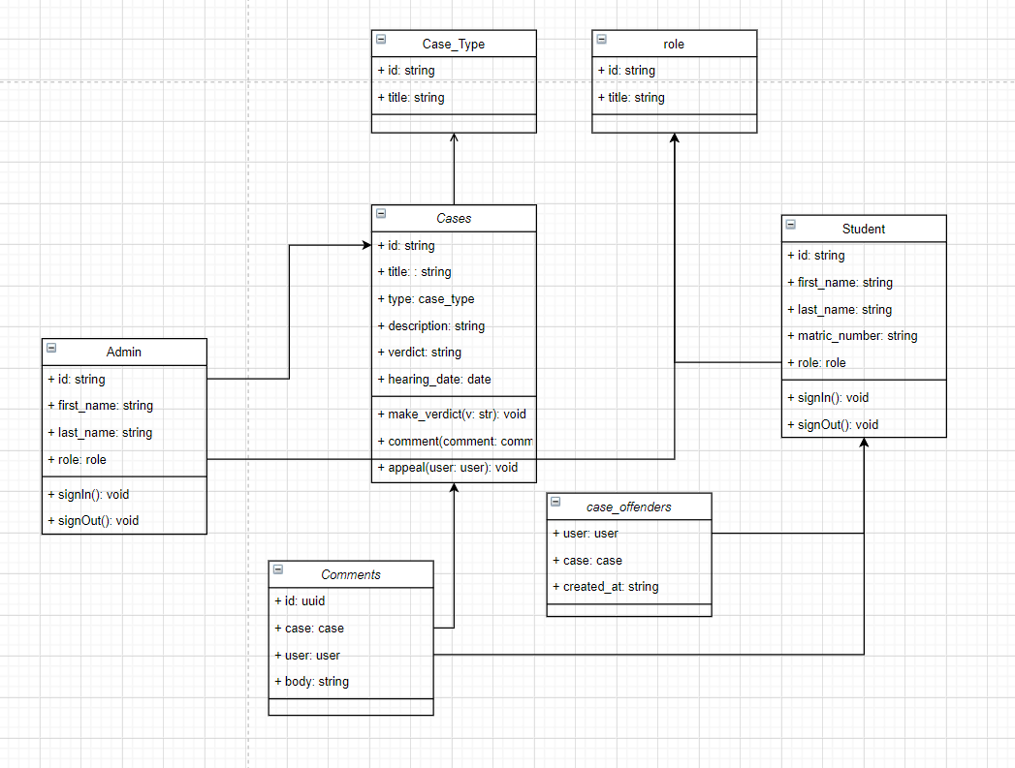

#### 3.12.4 System Requirements:

In terms of purpose, the system requirements are further divided into functional and non-functional. Functional requirements include creation of a new case, update on the same case at real-time, management on documents used in the case and security on the authentic user’s details. Some attributes that come under non-functional requirements are security of the data, response time of the system, availability of the system, and scalability of the system.

#### 3.12.6 Interface Design:

As an application, the graphical user interface and general layout of the SDC Application is friendly and effective. Figma is used for creating the graphical interface, as well as for creating demonstrations of it, making the designs as pleasant and easy to navigate as possible.

#### 3.12.7 Database Schema Design:

Diagrams of the database are designed and drawn using an online tool developed as dbdiagram. In this way, they provide assurance of a well-defined data framework in order to have a contingency and well-ordered organization. It includes entity-relationship diagrams of tables for users, cases, schools and many other necessary tables.

**Figure 7**

*Database schema design*

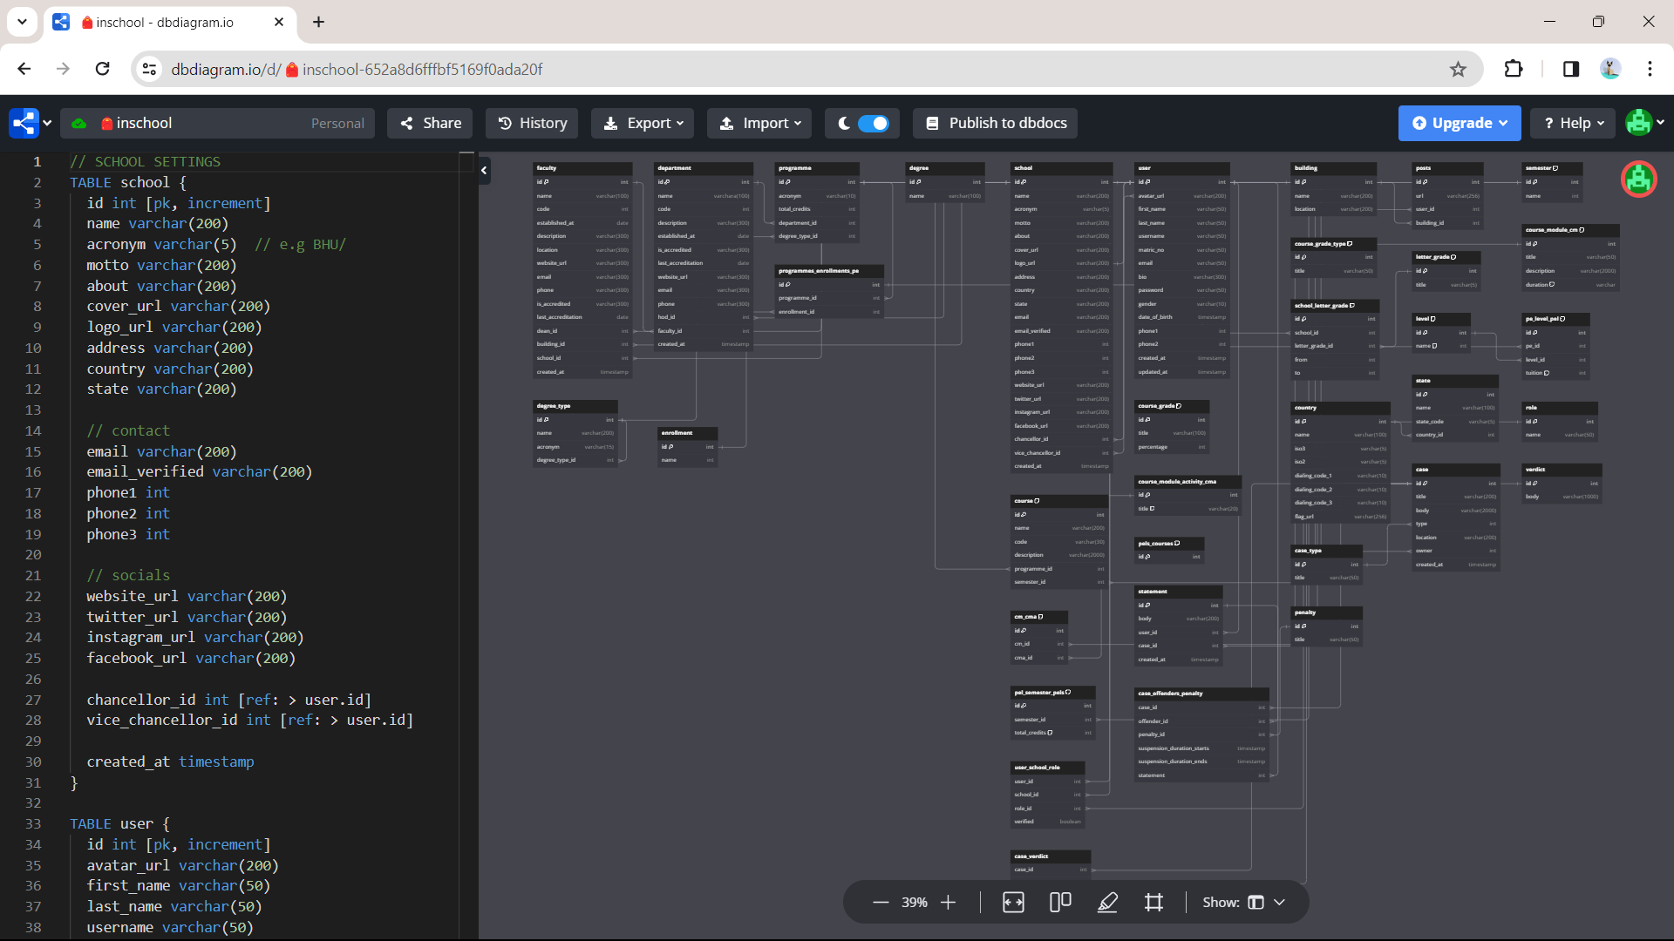

# ­­CHAPTER FOUR

## IMPLEMENTATION AND TESTING/RESULTS AND DISCUSSION

### 4.1 Implementation

The implementation of the Student Disciplinary Committee (SDC) Application contains several key aspects, including the design of screens for the mobile application, incorporation and usage of open source tools available, source control and tracking of modifications via the GitHub cloud based software.

#### 4.1.1 Design

The design of the mobile app screens was a critical aspect of the SDC Application development. The structure of the SDC Application mobile app screens was well developed. This work was designed using Figma, a collaboration tool that lets the creation of clickable interfaces for managing SDC cases to be easily developed. The concept followed the Taguchi concept of lay-out, emphasizing on the usability aspects, leading to the creation of easily transposable lay-out. They were created to provide an environment in which users can create new cases, include offenders to these cases, define case types, view cases and using various forms and descriptions give an understanding of what a case is. The below are some of the screenshots.

**Figure 8**

*Logo design*



**Figure 9**

*Splash screen and the login screen design*

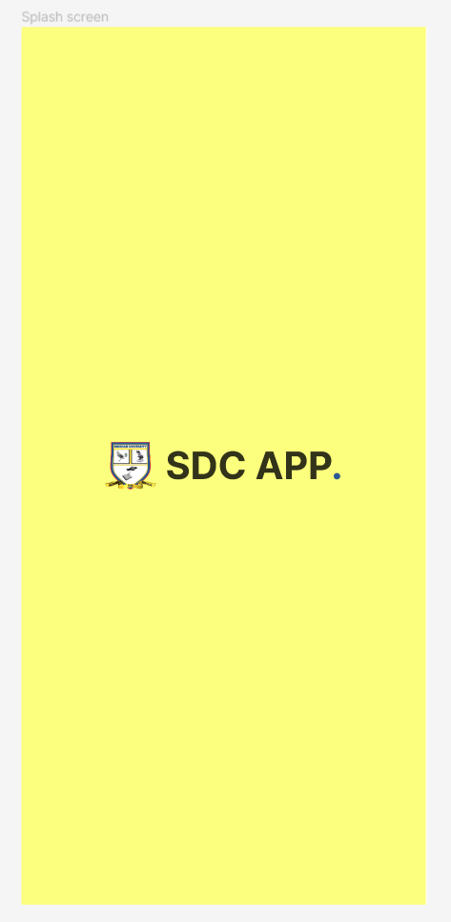 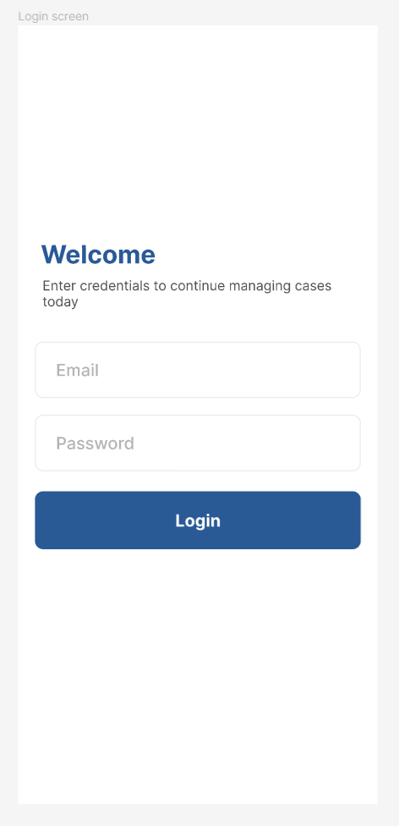

**Figure 10**

*The home screen design and a particular case screen design*

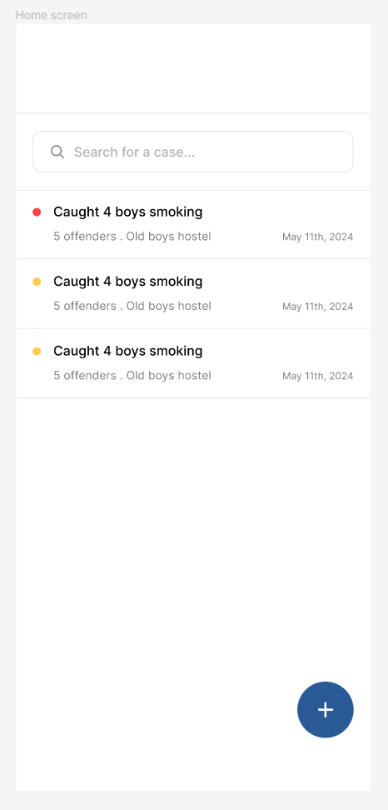 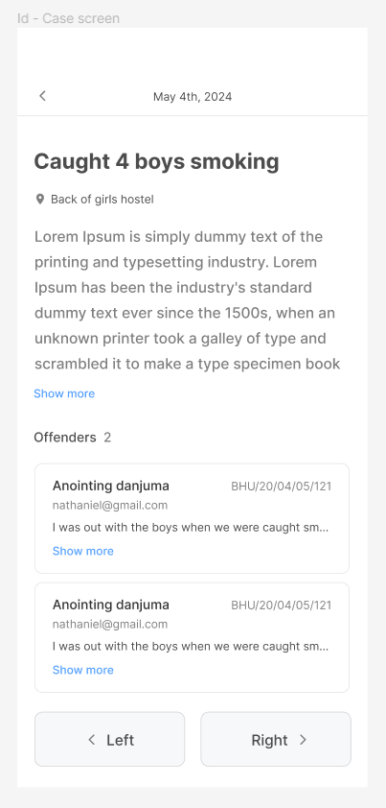

**Figure 11**

*The case form design and an offenders modal design*

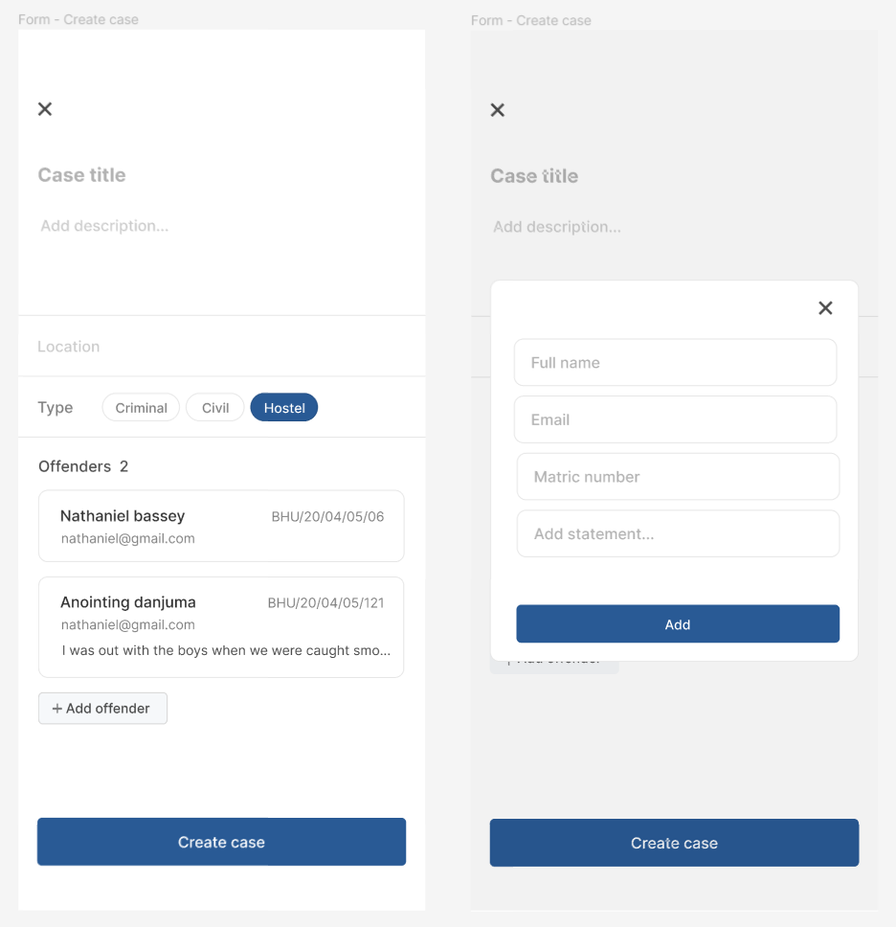

#### 4.1.2 Tools

Several open-source tools were instrumental in building the SDC Application:

**DrizzleORM:** Used for managing the application's database queries, providing a simple, lightweight and efficient way to handle interactions. And it’s also type safe, which makes it that much indispensable.

**TursoDB:** Employed as a serverless SQLite for production, offering a lightweight and scalable database solution.

**Zustand & React Query:** Used for managing the application's state and handling data fetching, providing a robust and efficient way to manage data (Very important).

**React Native & Expo SDK 51.0:** Utilized for building the mobile app, allowing for the development of cross-platform applications with a single codebase.

**Bun, Next API Routes & Hono:** These tools were used to build and run the backend code on the edge using the vercel platform, enabling faster performance and improved user experience.

**Figure 12**

*The backend deployed on vercel*

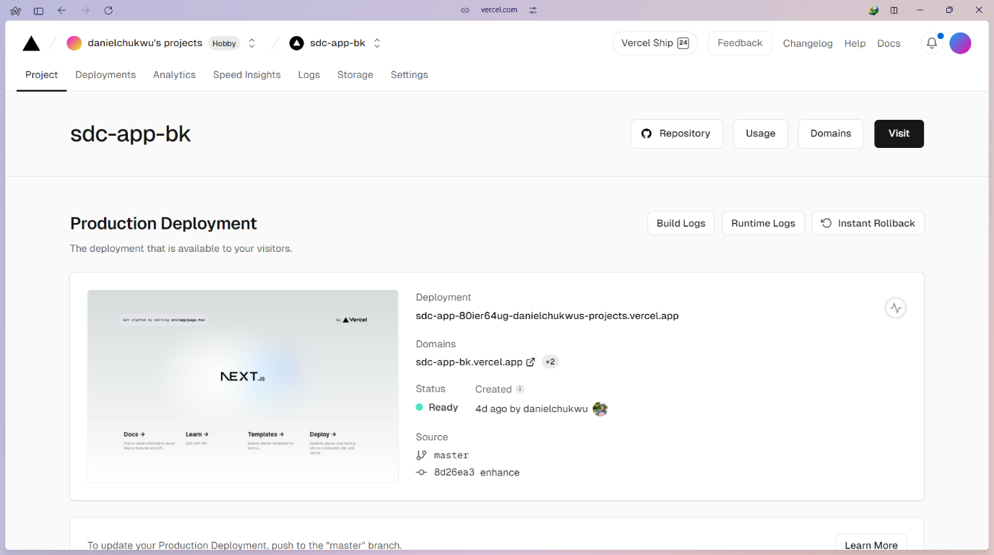

#### 4.1.3 GitHub Repository Codebase Screenshots

The backend and frontend codebases for the SDC Application were hosted in separate GitHub repositories. The backend repository contains the server-side code, including API endpoints and database interactions, while the frontend repository contains the code for the mobile app interface.

**Figure 13**

*The mobile interface github repository*

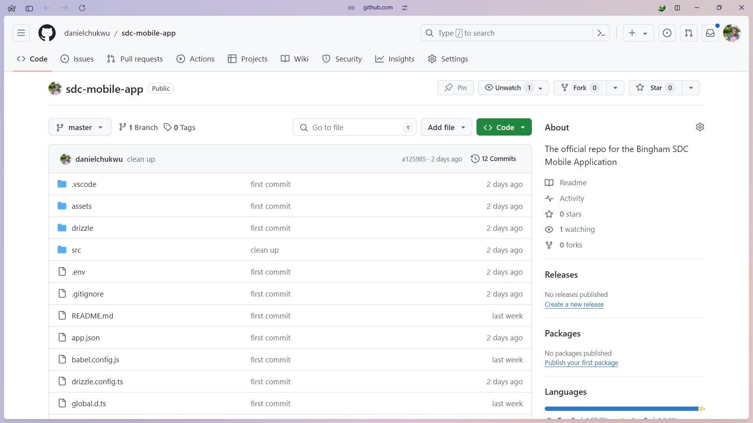

**Figure 14**

*The backend github repository*

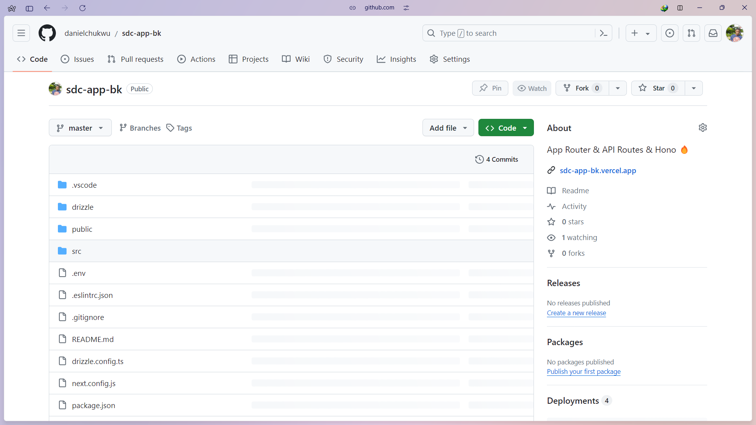

#### 4.1.4 Database Implementation

The database used for the Student disciplinary committee application (SDC) is SQLite production ready turso database, which provides an SQLite for Production service, it’s also a serverless solution that offers scalability and reliability for data storage. Turso SQLite for Production provides a CLI tool that enables developers to develop locally and easily switch to the hosted database in production.

**Figure 15**

*SDC application turso database*

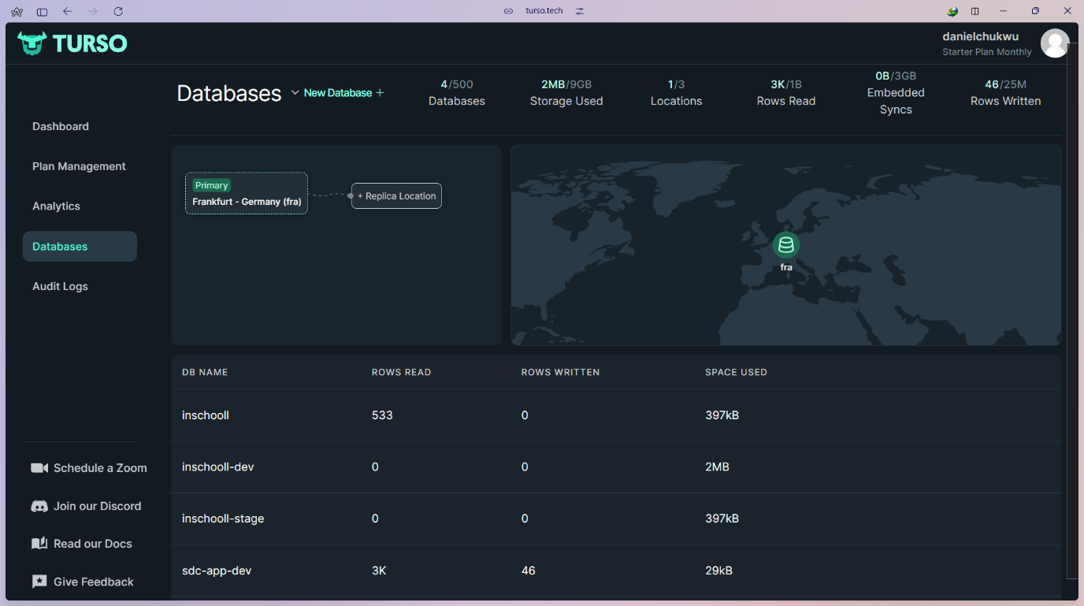

**Figure 16**

*Raw SQL JOIN query*

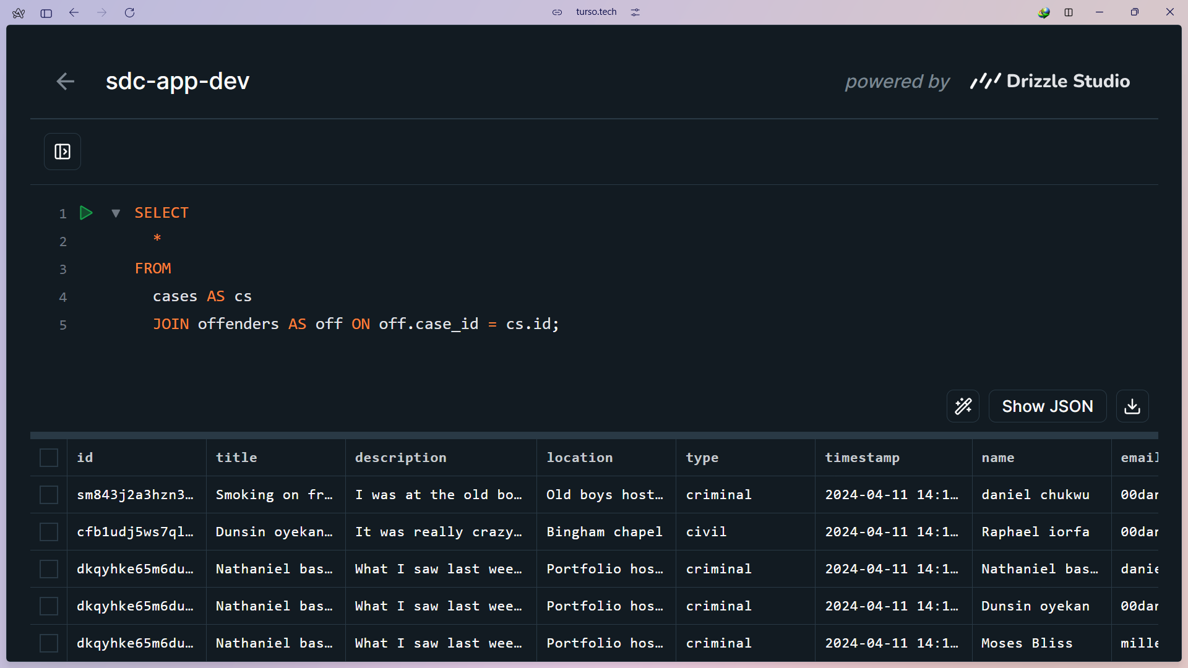

**Figure 17**

*Offenders’ database table*

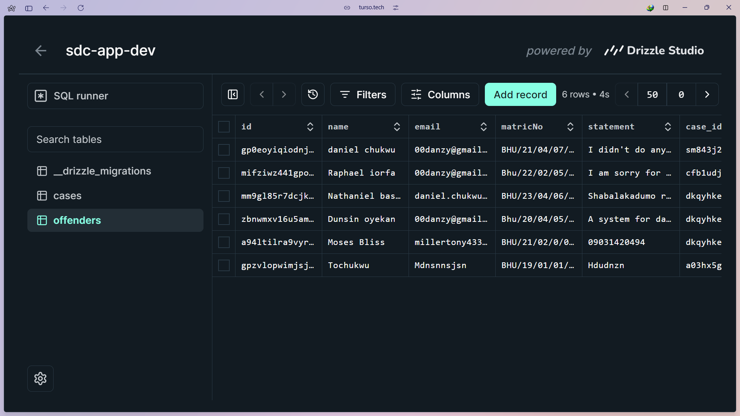

#### 4.1.5 Final product

The below figures show the result of the development process so far.

**Figure 18**

*Mobile app splash screen and login screen*

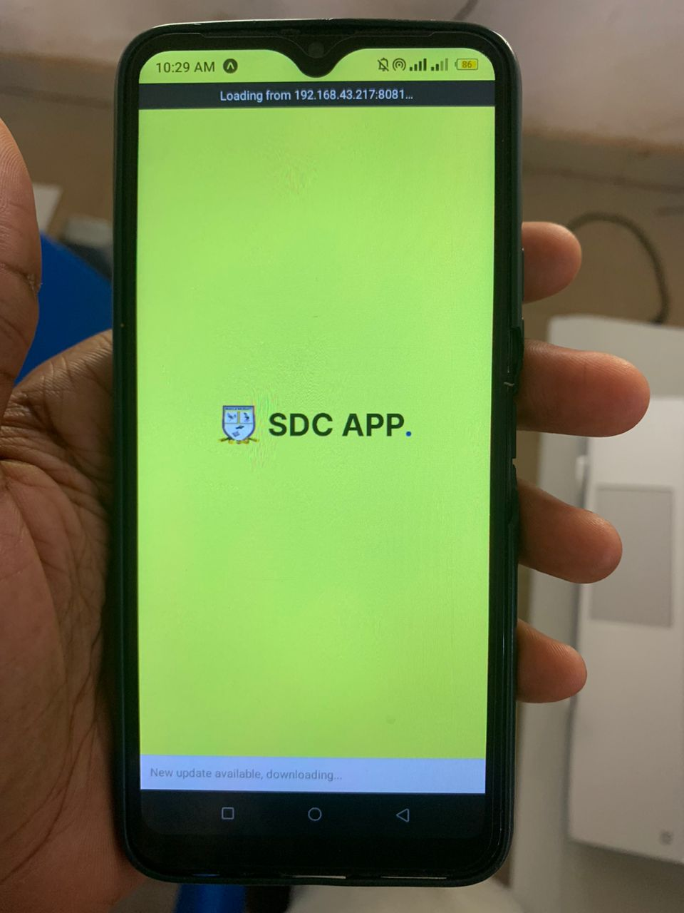 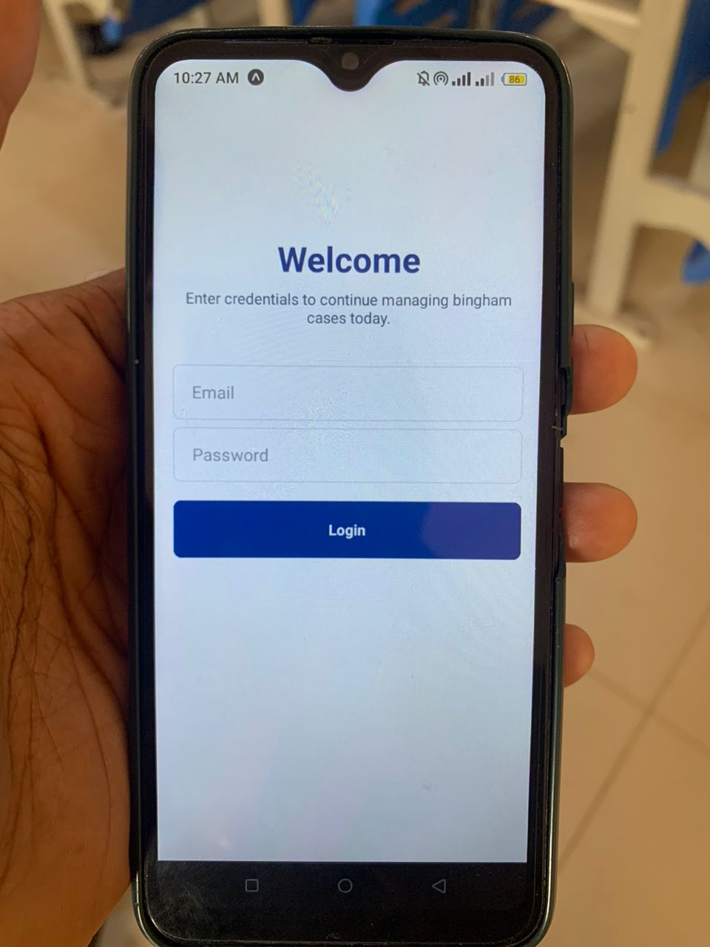

**Figure 19**

*List of cases screen and a particular case screen*

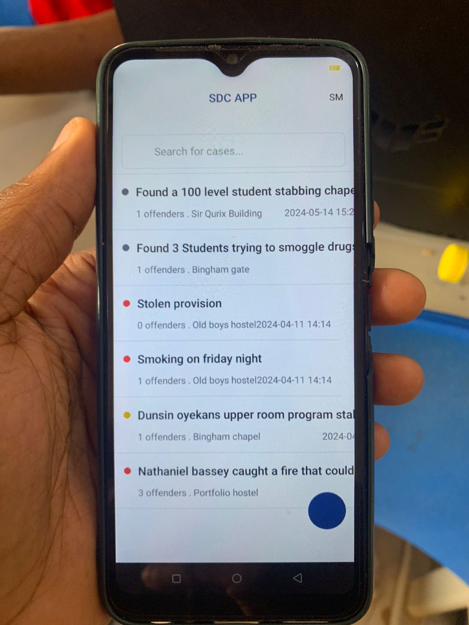 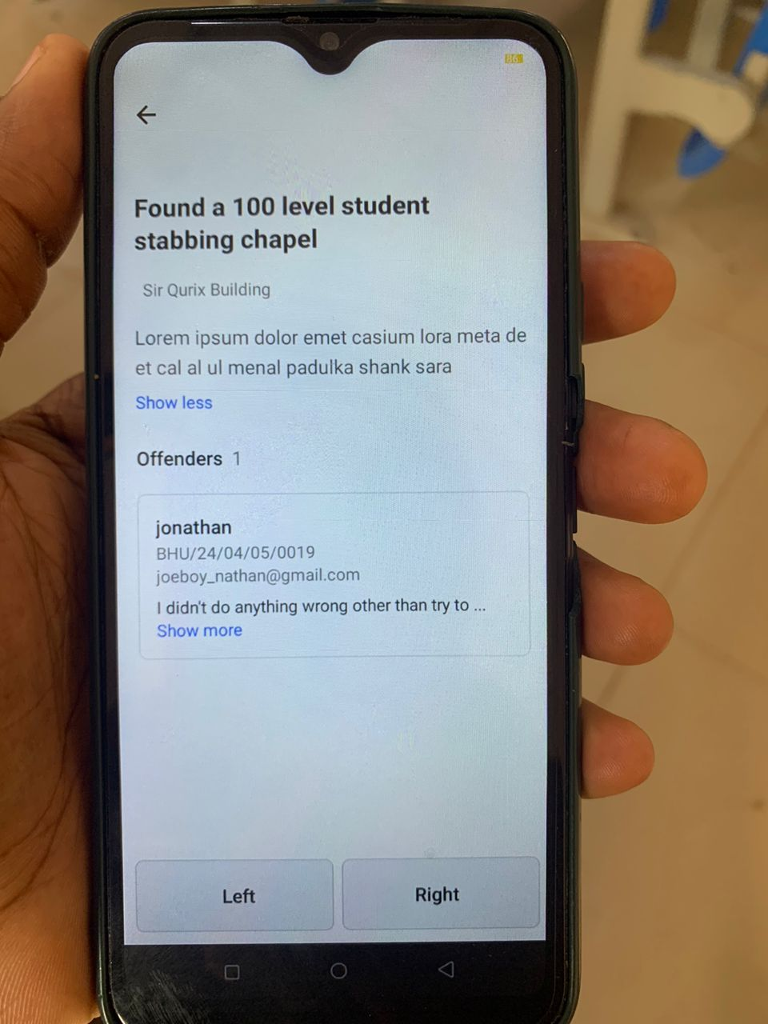

**Figure 20**

*Case creation screen and an offenders form dialog/modal*

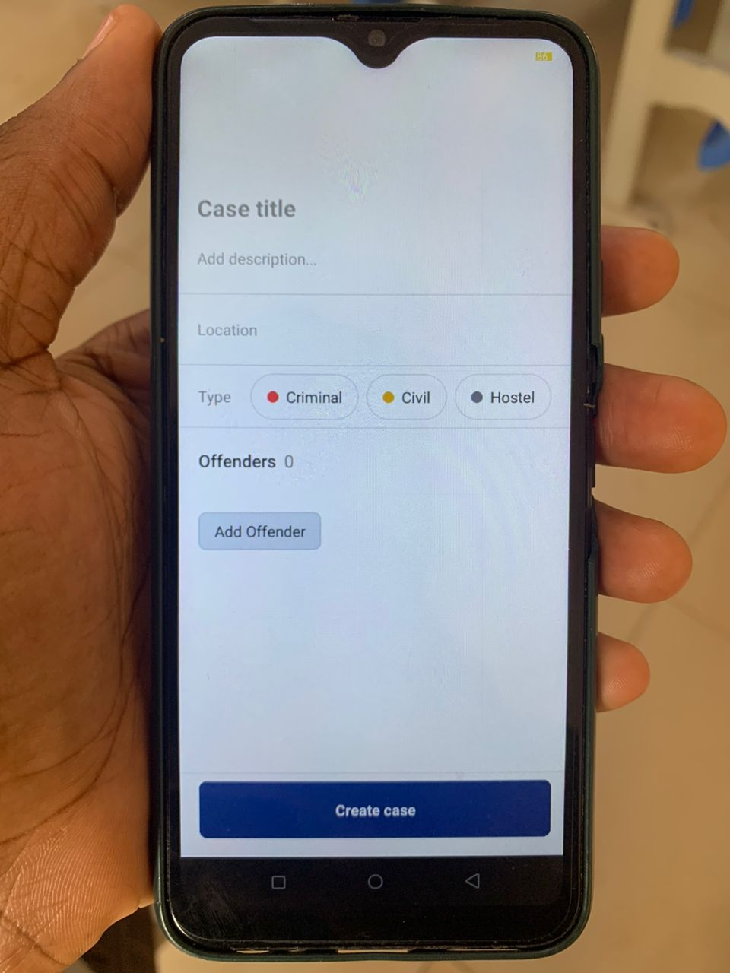

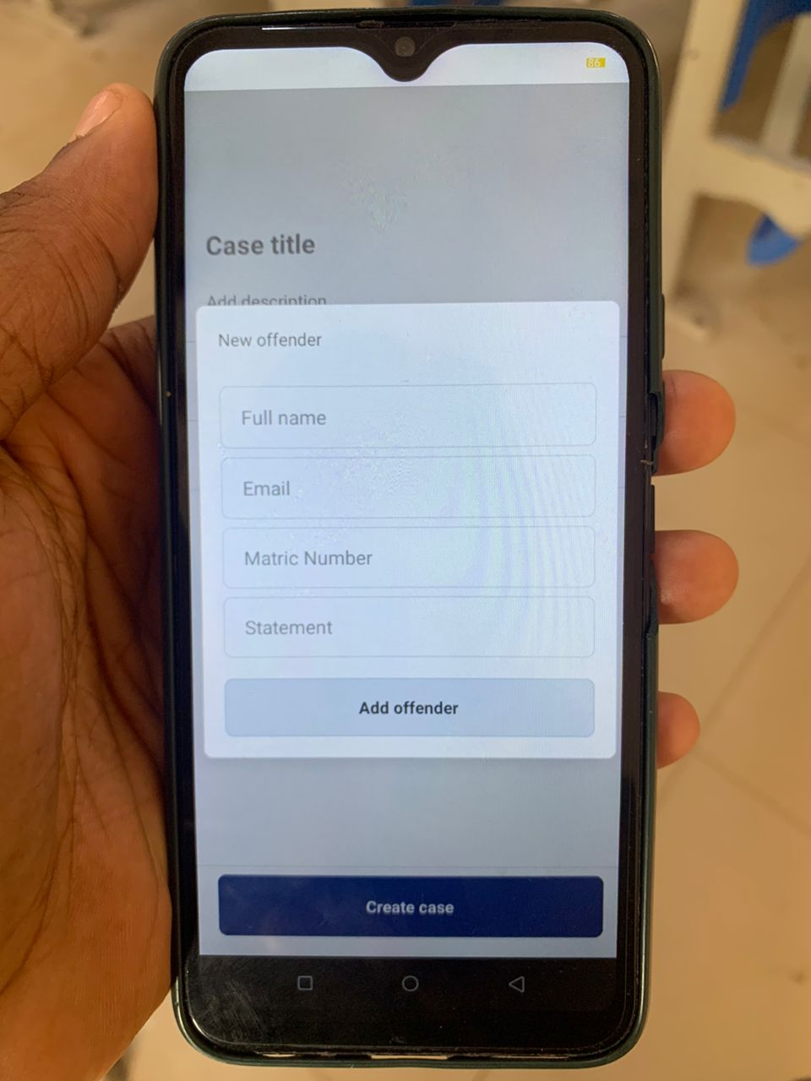

### 4.2 Testing

The testing of the SDC Application was carried out using the following libraries:

1. **jest:** Jest is an amazing, robust, industry-standard JavaScript Testing Framework used by some of the biggest tech companies in the world. It works with projects using: Babel, TypeScript, Node, React, and more. Hence making it a no brainer for the development of the SDC Application.
2. **react-test-renderer:** This package provides an experimental React renderer that can be used to render React components into pure JavaScript objects, without depending on the DOM or a native mobile environment in our case. Which is extremely important.

By using Jest and react-test-renderer, the testing process for the SDC Application is streamlined, making it possible to write more comprehensive tests for the app's components and functionalities.

#### 4.2.1 Unit Testing

Jest and react-test-renderer libraries were used to unit test all the application components and utility functions. The screenshots below show some of these tests.

**Figure 21**

*Test files*

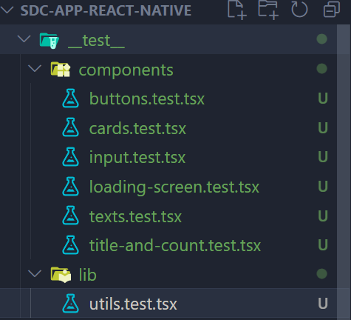

**Figure 22**

*Unit test code for a card component*

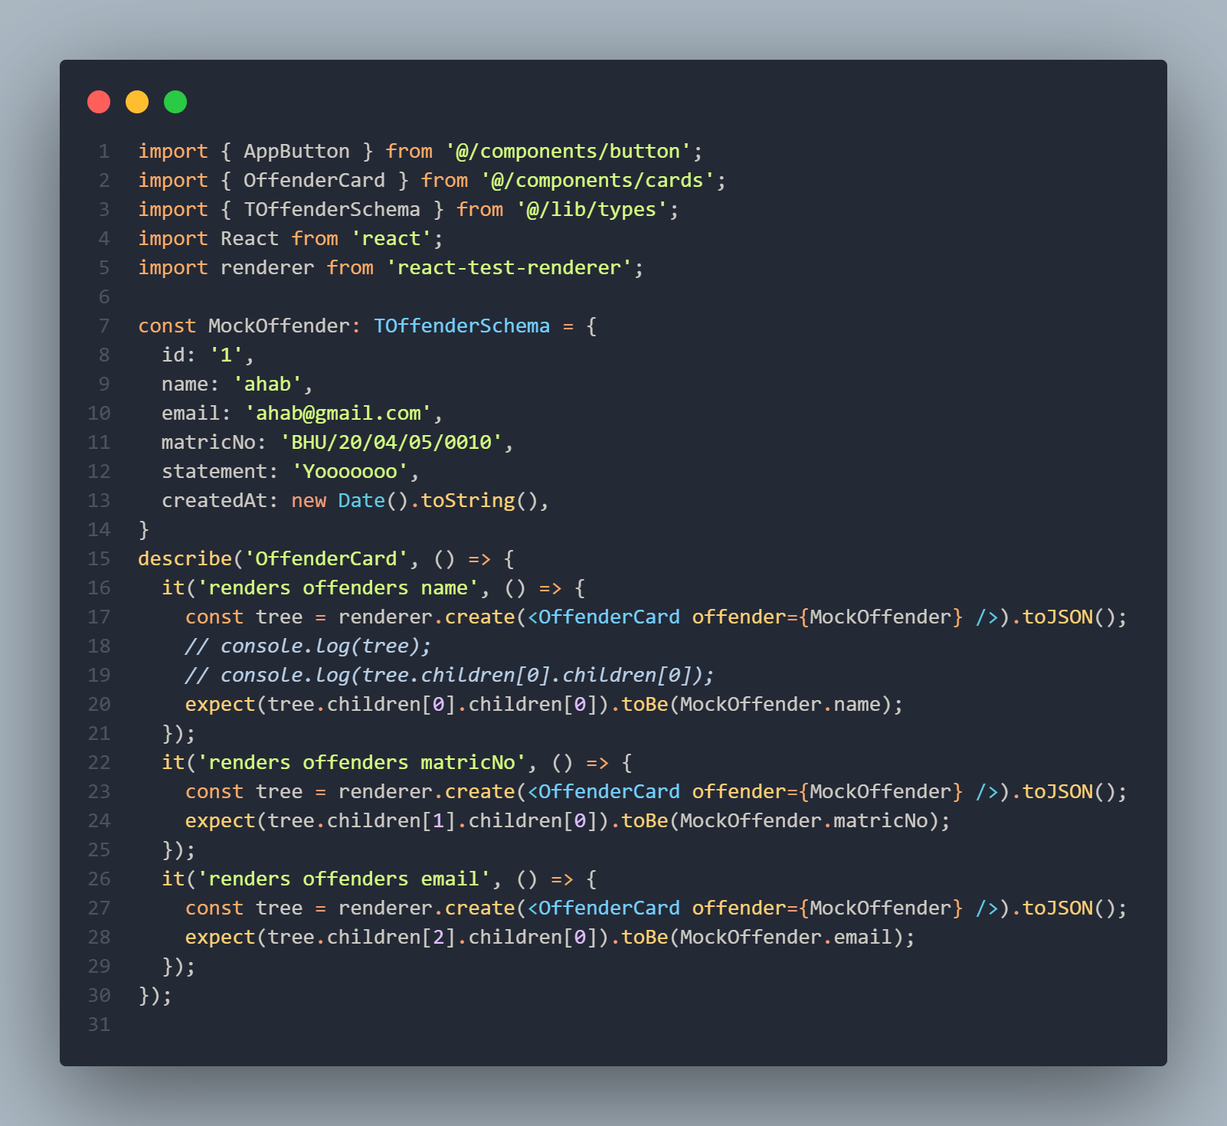

**Figure 23**

*Executed test results*

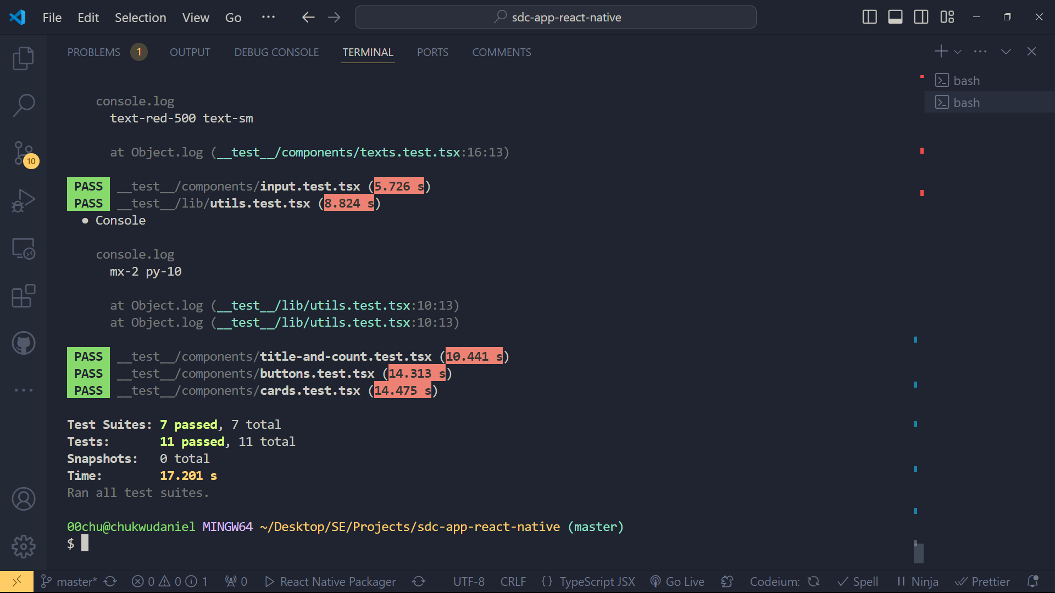

# CHAPTER FIVE

## SUMMARY, CONCLUSION AND RECOMMENDATION

### 5.1 Summary

The intended goal of this project was to design a mobile application to address the need for a Student Disciplinary Committee Application (SDC) to enhance the process of handling disciplinary cases among universities. A set of key recommendations was collected with these general ideas about design and features of the application as a result of a qualitative research that included a quantitative part, which included interviews with the users, case studies, observations. Agile was used as the project development methodology given that it is highly flexible and requires constant engagement with the stakeholders.

#### 5.1.1 Major Findings:

**i. Design and Development:**

The mobile app screens were developed to give friendly user interface to interact when handling cases of discipline. It interesting to note that the project utilized different types of open-source tools among them being DrizzleORM, TursoDB, React Query, React Native, and Expo SDK 51. 0, Bun, Next API Routes, and Hono are all examples of the diverse applications of API routes. To keep the codebase of the backend and the frontend organized, the two codes were hosted on different GitHub repository.

**ii. Database Implementation:**

TursoDB (an SQLite for production database) was employed as the database solution for the application, as it comes with a ton of helpful, out-of-the-box features that aid developers in building apps faster and paying much more attention to the development of the product rather than the managing of a physical server and having to handle all the bottlenecks that come with going down that part.

**iii. Testing:**

Jest and react-test-renderer were adopted to guarantee the application’s reliability and its ability to run through diverse tests. These tools enabled the comprehensive testing of individual elements(units) and the whole platform of the Web Application to be implemented on mobile devices without involving the DOM or the native environments for the mobile devises.

**iv. Challenges Encountered:**

Interoperability was one issue using multiple tools needed a lot of coordination and compatibility tested needed to be conducted. One of the major technical issues that remained a concern for the company was implementing adequate data security and making sure that system could be easily scaled. It was very challenging to get a broad range of user feedback into one paper, so it was important to carefully plan and execute the process.

### 5.2 Conclusion

From the SDC Application project, it is now obvious that technology plays a crucial role in the efficiency of disciplinary cases management in schools. The modern tools in software development and the efficient methodologies employed paved way for building a sound and very friendly application. First, the research methodology conducted during the project was effective in all aspects of it by identifying the key requirements and possible issues in planning, designing, development, implementation, and evaluating the project of a social media platform for promoting education among the youth. These studies point to the conclusion that the extension of disciplinary procedures through digital channels makes them more open and understandable, improves communication between participants, and simplifies the work of both administrators and students.

### 5.3 Recommendation

Based on the findings of the study, the following recommendations are proposed:

**Wider Implementation:** Universities should consider adopting similar digital solutions to streamline their disciplinary processes. The SDC Application can serve as a model for other institutions seeking to enhance their case management systems.

**Continuous Improvement:** The application should be updated from time to time where possible taking into consideration the feedback from the users and the new features they may require in the course of their activity. Also, some updates and maintenance should be constantly done regularly so that it can remain effective and secure.

**Training and Support:** All users, including the SDC members should undergo comprehensive programs of training in the use of the application. The users will require help to get the best out of the application through technical support being provided at later intervals.

**Further Research:** Further study should examine the organizational culture and students’ behavior changes over a long time in institutions where such digital disciplinary systems have been implemented. Furthermore, there are other options to improve the model, including additional functional opportunities like the utilization of artificial intelligence in analytics and report generation automation.

## References

Blandford, S. (1998). Google Books. https://books.google.com.ng/books?hl=en&lr=&id=13oaXCiHbqAC&oi=fnd&pg=PT10&dq=discipline+in+schools&ots=8As7gpBeVD&sig=7DsMbOiKdVSHXb2KOiqoyHJfYpg&redir_esc=y

Mao, J., Vredenburg, K., Smith, P. W., & Carey, T. (2005). The state of user-centered design practice. Communications of the ACM, 48(3), 105–109. https://doi.org/10.1145/1047671.1047677

Hung, L. D. (2023). *Web Development with T3 stack*. Theseus. https://www.theseus.fi/handle/10024/802481

Esfahani, H. C., & Yu, E. (2010). A repository of agile method fragments. In *Springer eBooks* pp. 163–174). https://doi.org/10.1007/978-3-642-14347-2_15

Diego L. Villarreal. (2021, March 8). Students Constitutional Rights and The University Disciplinary Committee. https://heinonline.org/HOL/LandingPage?handle=hein.journals/ncclj3&div=9&id=&page=

Karlesky, J. J., & Stephenson, D. G. (1971). Student disciplinary proceedings: Some preliminary questions. The Journal of Higher Education, 42(8), 648–656. https://doi.org/10.1080/00221546.1971.11774894

Smith R. Reddick. (2020). Due Process Rights in Student Disciplinary Matters. https://heinonline.org/HOL/LandingPage?handle=hein.journals/jcolunly14&div=17&id=&page=

J. Crim. L. & Penal Stud. (2019). The Authority of Disciplinary Committee for Students to Oblige Third Parties to a Specific Behavior. https://heinonline.org/HOL/LandingPage?handle=hein.journals/jlocllwap23&div=34&id=&page=

Notar, C. (2009, September 1). DISCIPLINARY ACTION COMMITTEE (DAC). | Education | EBSCOhost. https://openurl.ebsco.com/EPDB%3Agcd%3A10%3A1154874/detailv2?sid=ebsco%3Aplink%3Ascholar&id=ebsco%3Agcd%3A44016929&crl=c

Julia pedley. (2007). THE DEVELOPMENT OF A STUDENT CONTRACT AND IMPROVEMENT IN STUDENT DISCIPLINARY PROCEDURES AT MASSEY UNIVERSITY. https://heinonline.org/HOL/LandingPage?handle=hein.journals/anzled12&div=8&id=&page=

Ira Michael Heyman. (2022). Some Thoughts on University Disciplinary Proceedings. https://heinonline.org/HOL/LandingPage?handle=hein.journals/calr54&div=13&id=&page=

James M. Picozzi. (2020). University Disciplinary Process: What's fair, What's Due, and What You Don't Get. https://heinonline.org/HOL/LandingPage?handle=hein.journals/ylr96&div=87&id=&page=

Bayrami, M. (2020, April 21). A Comparison of Personality Characteristics and Coping Strategies in Students with Record in Disciplinary Committee of University and Normal Students. https://psychologyj.tabrizu.ac.ir/article_4213.html?lang=en

Ige (2016). Factors influencing disciplinary committee effectiveness: the case of public secondary schools in Ondo State, Nigeria. DigitalCommons@Fayetteville State University. https://digitalcommons.uncfsu.edu/jri/vol4/iss3/3/

Peter J.O. Aloka & Olaniyi Bojuwoye. (2023). Gender differences in decisions on student disciplinary behaviours by disciplinary panels of selected Kenyan secondary schools. https://journals.co.za/doi/abs/10.10520/EJC136364

Edward N. Stoner II & Bradley J. Martineau. (2019). Disciplinary and Academic Decisions Pertaining to Students in Higher Education. https://heinonline.org/HOL/LandingPage?handle=hein.journals/jcolunly27&div=20&id=&page=

Papadakis, M. A., Hodgson, C. S., Teherani, A., & Kohatsu, N. D. (2004). Unprofessional Behavior in Medical School Is Associated with Subsequent Disciplinary Action by a State Medical Board. Journal of Medical Regulation, 90(1), 16–23. https://doi.org/10.30770/2572-1852-90.1.16

Wilson, J. M. (1996). Processes for resolving student disciplinary matters. New Directions for Student Services, 1996(73), 35–52. https://doi.org/10.1002/ss.37119967305

Tamu K. Walton (2019). Protecting Student Privacy: Reporting Campus Crimes as an Alternative to Disclosing Student Disciplinary Records. https://heinonline.org/HOL/LandingPage?handle=hein.journals/indana77&div=10&id=&page=

Daud, N. M., & Mohamed, I. S. (2009). Evaluating technology resistance and technology satisfaction on students’ performance. *Mendeley*, *26*(4), 298–312. https://doi.org/10.1108/10650740910984637